**MINI-PROJECT REPORT**

Customer Wallet Record



**NAME: - Ramana Govardhan Reddy**

**PS NO: 99007575**

**TABLE OF CONTENTS**

|  |  |  |
| --- | --- | --- |
| **SERIAL No.** | **CONTENT** | **PAGE No.** |
| 1 | Introduction | 3 |
| 2 | Objective | 3 |
| 3 | Features | 3 |
| 4 | 4 W’s 1H | 4 |
| 4 | SWOT Analysis | 5 |
| 3 | Requirements | 6-7 |
| 4 | Architecture | 8-9 |
| 5 | Test Plan | 10 |
| 6 | Expected results/Outcomes | 10-12 |

**Introduction:**

* The growth in business also lead to the growth in the need of E-billing applications using Wallets Records where all the information regarding the customer transanctions in that departmental store can be maintained online.
* Customer Wallet Record (Cutomer Billing System) is a console based application where a customer can create and maintain an account. This account contains all the information of the customer and also the account can be edited as and when required.

# Objective:

* The main aim of Customer Wallet Record (Customer Billing System) is to maintain the information and payment history of the customer.It has the capacity to illustrate and analyze the basic billing system and the main functionalities that surround the billing system from a business prospective and explains how each interacts to complete the billing cycle. It capable of billing more quickly, accurately and update customer record and enables customer to view bill information.

# Benefits:

* A customer can create an account for his own and give his details such as address to be stored.
* This helps the store to provide home delivery to the customer.
* The billing history of the customer is maintained.
* The customer can maintain some amount as balance to pay cash less as and when required in any brach of that departmental store.
* The customer can edit the information in his account as and when required.

### **Features**

* To create New Account
* To update the existing account
* To print information of all the customers
* To search for an account
* Adding Amount to Existing Customer's Wallet

# Who:

* This is to maintain the record of customers in local stores.

# What:

* This apllication is designed for local grocery stores to manage and maintain a record of customers.

# Why:

* As we all know in local grocery stores they use books to maintain a record which may be gone or teared etc. By this application the store managers and a customer can maintain there own record and analyse their recors like balance of amount, his information etc.

# Where:

* This application is mainly developed for local stores.

# How:

* Wallet record is an application that will take input from user or store management such as customer details then it will create account for that customer in the memory and stores every reco

## **SWOT Analysis**

### **Strengths**

* String Relationship with Existing suppliers.
* Faster and Accurate Billing.
* Customer can go cashless if they have balance in the account.

### **Weaknesses**

* Application would not work in case of network issues.
* Maintaining a huge database with growing customers can be tedious.

### **Opportunities**

* Home delivery facility can be provided.
* Any information regarding product restocking and new arrivals can be easily conveyed.

### **Threats**

* Can be easily replicated.
* The customers data can be stolen.

**REQUIREMENTS**

## **High Level Requirements**

| **ID** | **Description** | **Category** | **Status** |
| --- | --- | --- | --- |
| HR01 | New customer can create account | Techinal | TBI |
| HR02 | Customer can mantain a Balance | Technical | TBI |
| HR03 | Customer information can be displayed | Technical | TBI |
| HR03 | Customer can pay the bill from e-wallet | Techinal | TBI |
| HR04 | Customer can maintain money in account's wallet | technical | TBI |
| HR05 | The last transaction amount of the custmoer in the store have to be maintained | Technical | TBI |
| HR06 | Customer can opt for home delivery | Technical | FUTURE |
| HR07 | The data should not be lost during failure | Scenario | FUTURE |
| HR08 | The information of the customer sould not be leaked | Scenario | FUTURE |
| HR09 | All the tracsanctions fron the creation of the account have to be maintained | Technical | FUTURE |

## **Low Level Requirements**

| **ID** | **Description** | **HRID** | **Status** |
| --- | --- | --- | --- |
| LR01 | For Each new account a new array cell of structure type have to be created | HR01 | TBI |
| LR02 | Balance can be mantanied by creating a structure array each cell holding information of the user and their balance | HR02 | TBI |
| LR03 | Customer information can be displayed by printing the structure array | HR03 | TBI |
| LR04 | When paying bill the balance attribute is modified and updated | HR04 | TBI |
| LR05 | The home delivery option cane be implemented by taking the address of the customer | HR06 | FUTURE |
| LR06 | The data can be protected by using file to store all the data | HR07 | FUTURE |
| LR07 | The authentication mechanisms have to be implementd to prevent data leakage | HR08 | FUTURE |
| LR08 | All the transactions can be maintained in a file dedicated to that customer | HR08 | FUTURE |

**Architecture:**

# Flow Diagram

[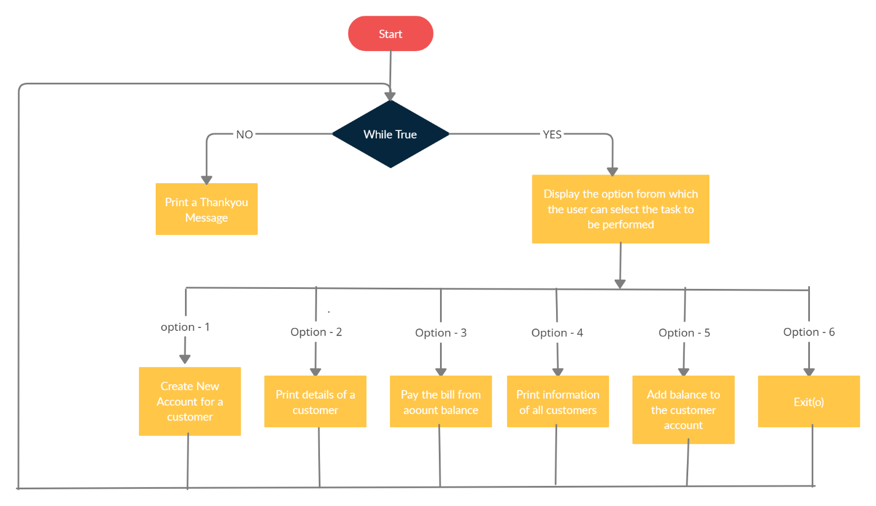](https://github.com/A123456fgh/M1_application_customerswalletrecord/blob/main/2_Architecture/FlowDiagram.png)

# Use Case Diagram

[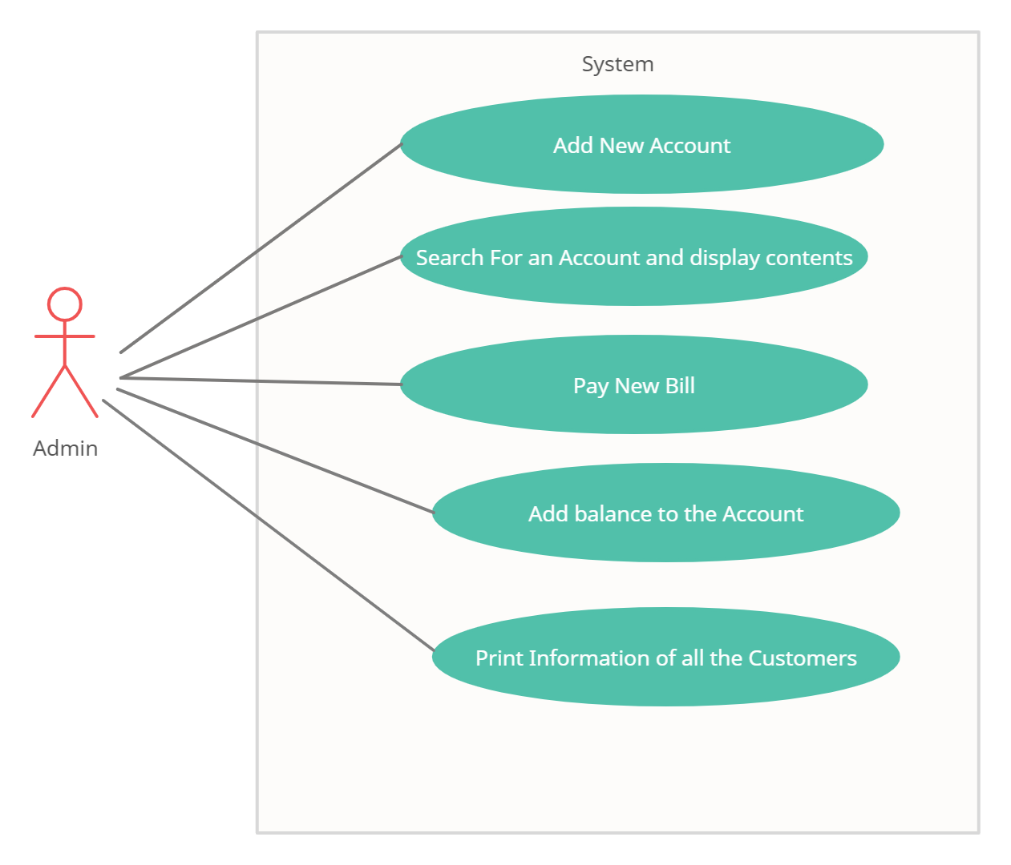](https://github.com/A123456fgh/M1_application_customerswalletrecord/blob/main/2_Architecture/usecase.png)

**TEST PLAN: -**

| **Test_ID** | **Description** | **Expected_input** | **Expected_output** |
| --- | --- | --- | --- |
| H_01 | To check whether the name variable is given in strings or not | strings without spaces | Name variable should be assigned with the given string |
| H_02 | check Whether the mobile number given contains only 10 digits | 10 digit integer | The 10 digit number should be assigned to mobile Information placeholder |
| H_03 | Checking whether the amount which customer wants to pay is less than or equal to his wallet balance | 1.Floating point value 2. integer | Debit the used amount from Customer's wallet and update the new balance in real-time |

**Output Images:**



